**MIDDLETON CHENEY FOOTBALL CLUB**

**ANNUAL GENERAL MEETING**

**1994**

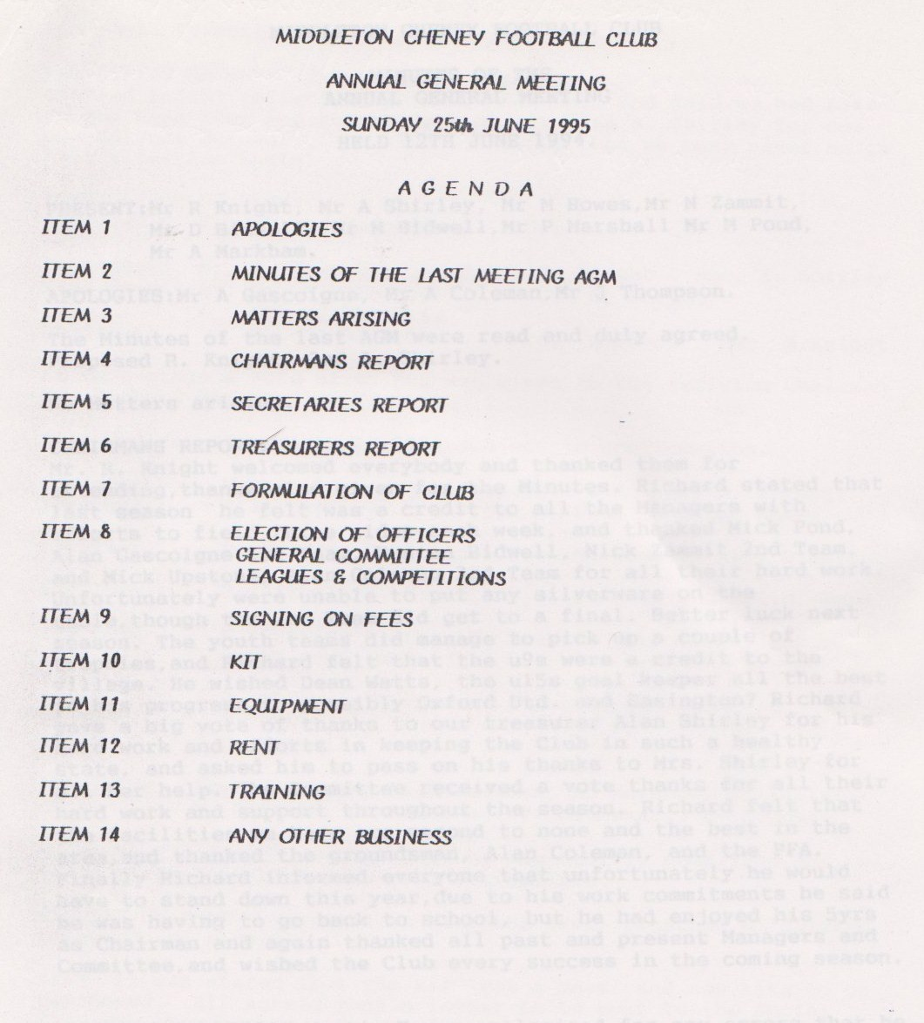

**Continued**

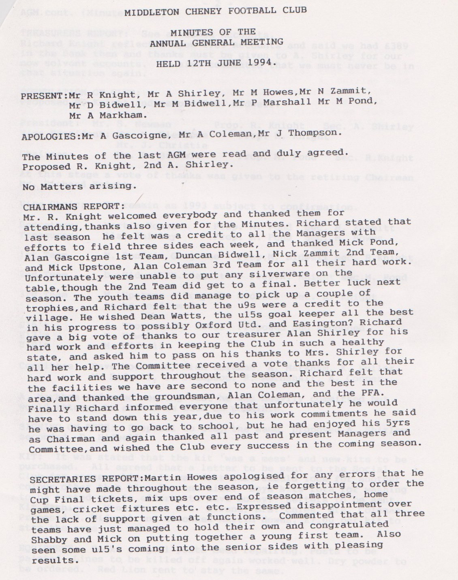

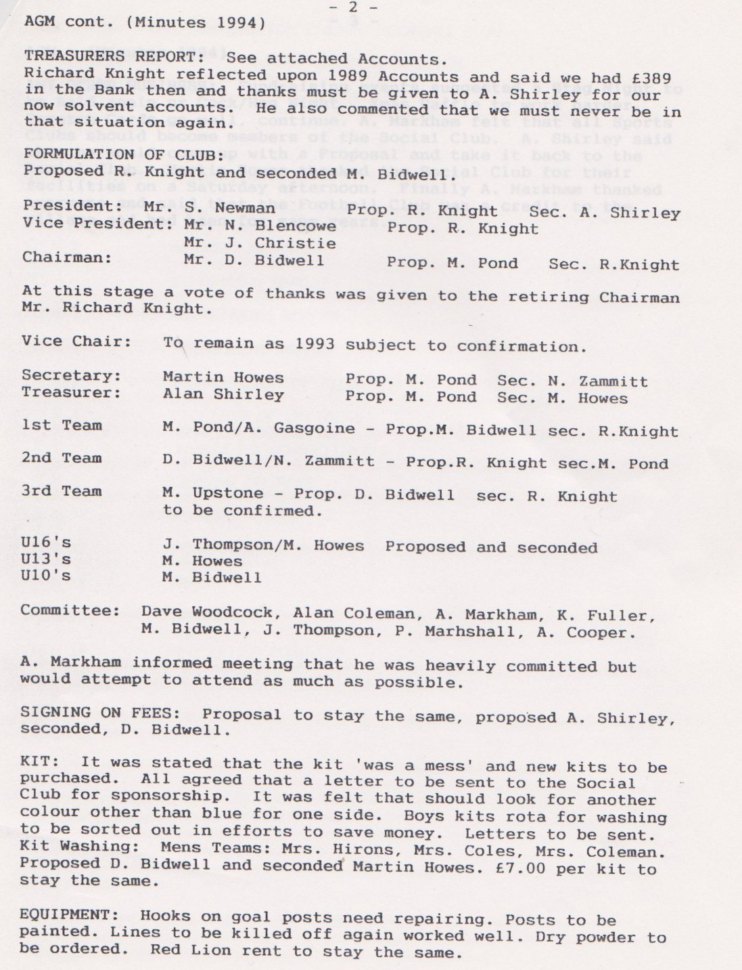

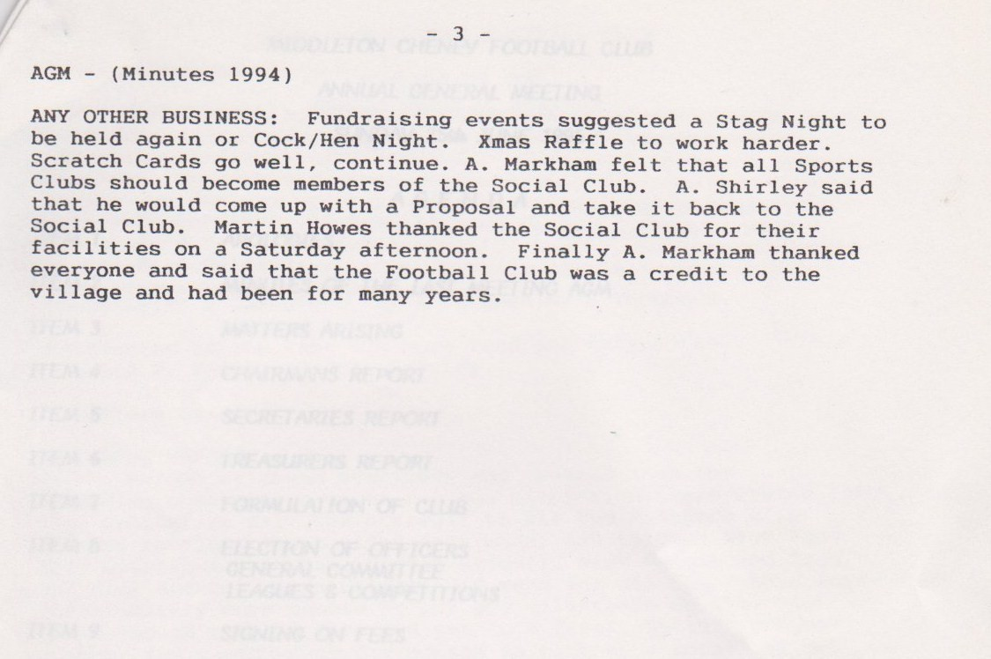

**General Committee Meeting**

**August 7th 1994**

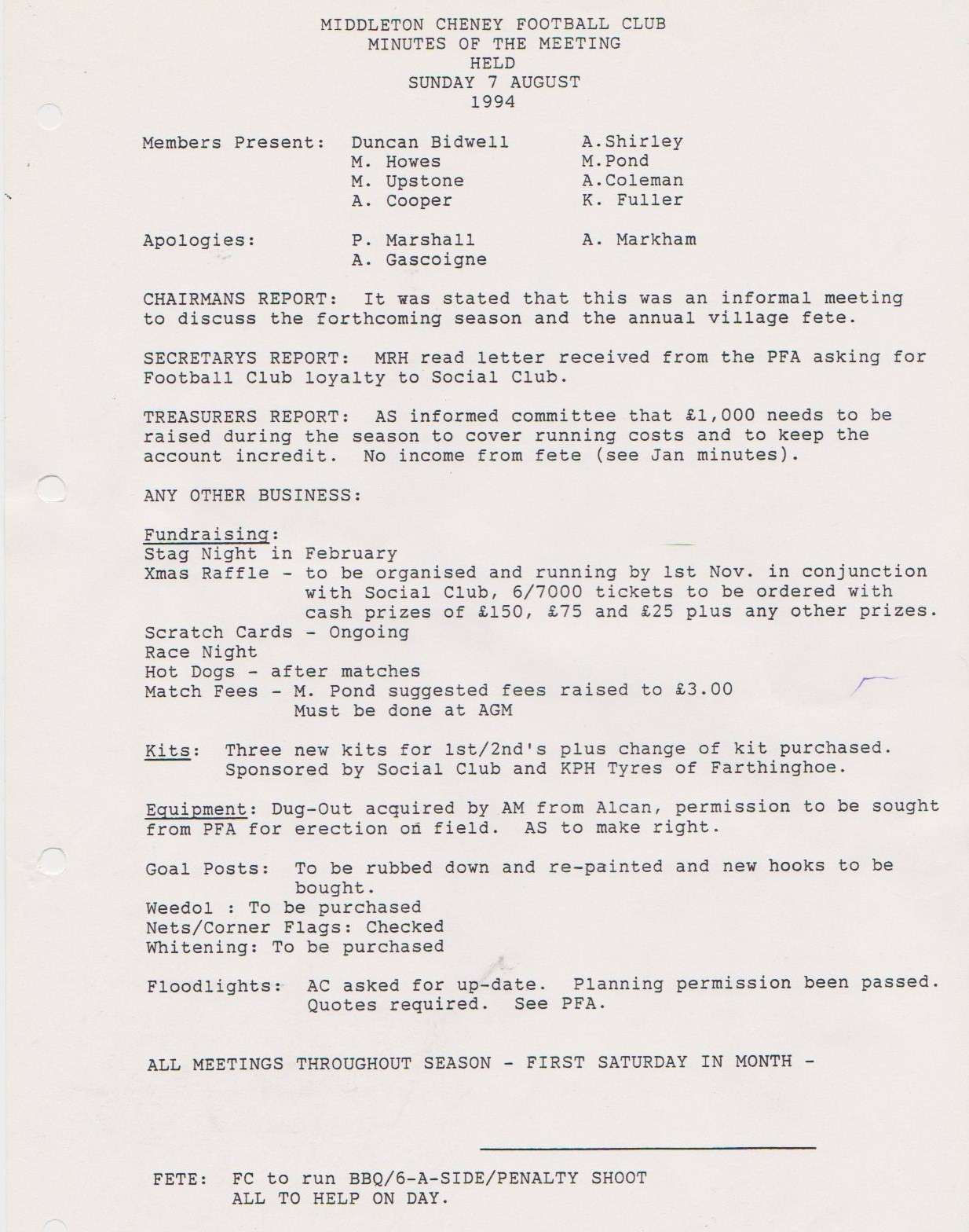

**General Committee Meeting**

**September 10th 1994**

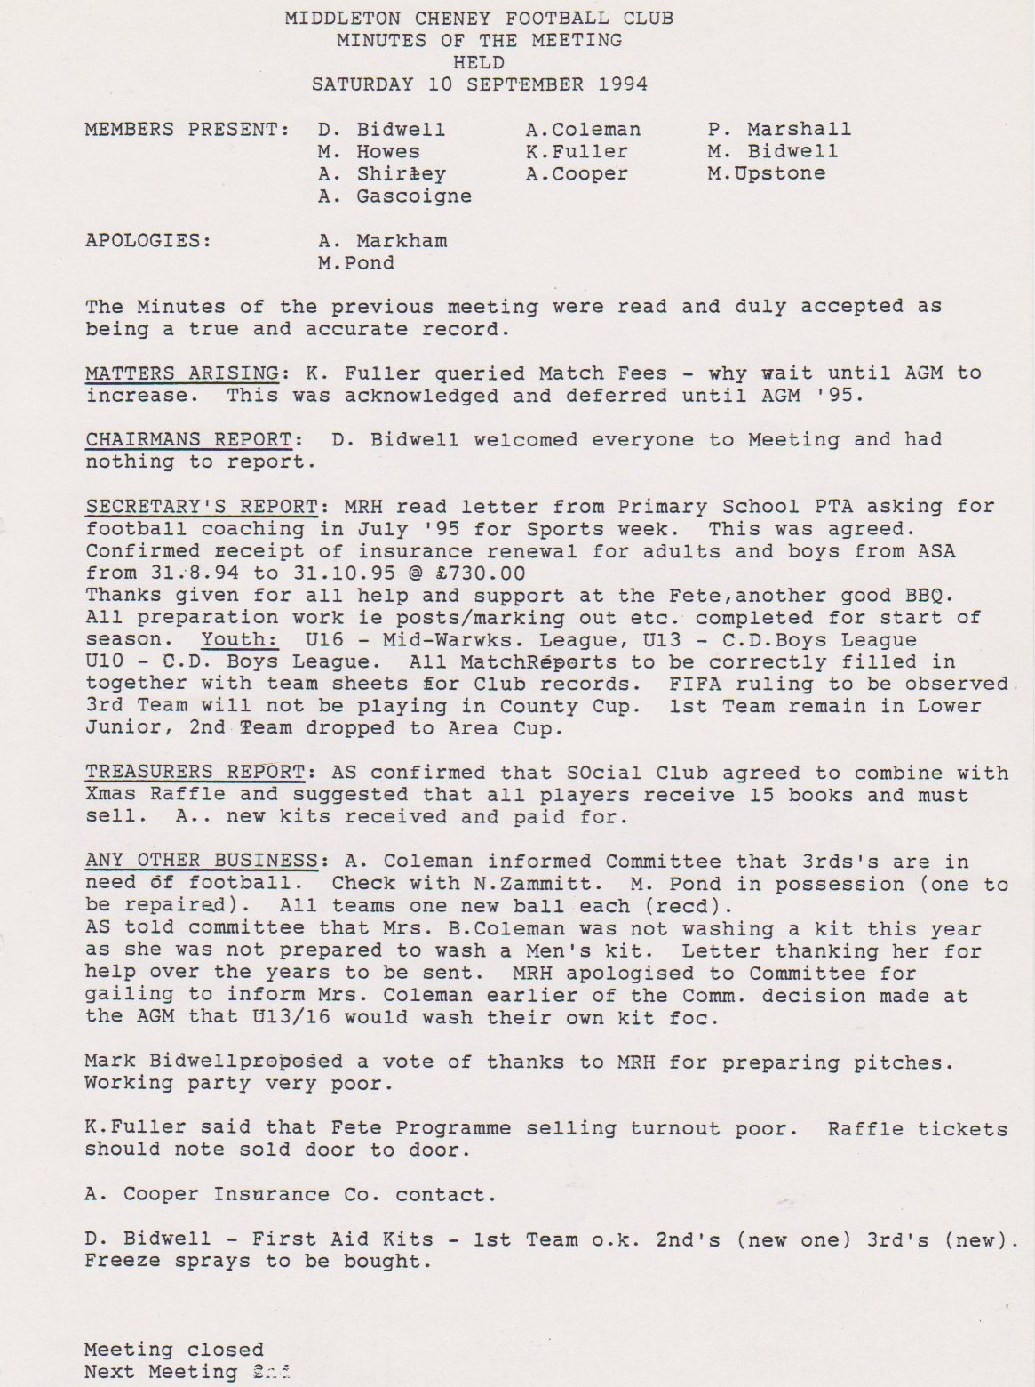

**General Committee Meeting**

**October 1st 1994**

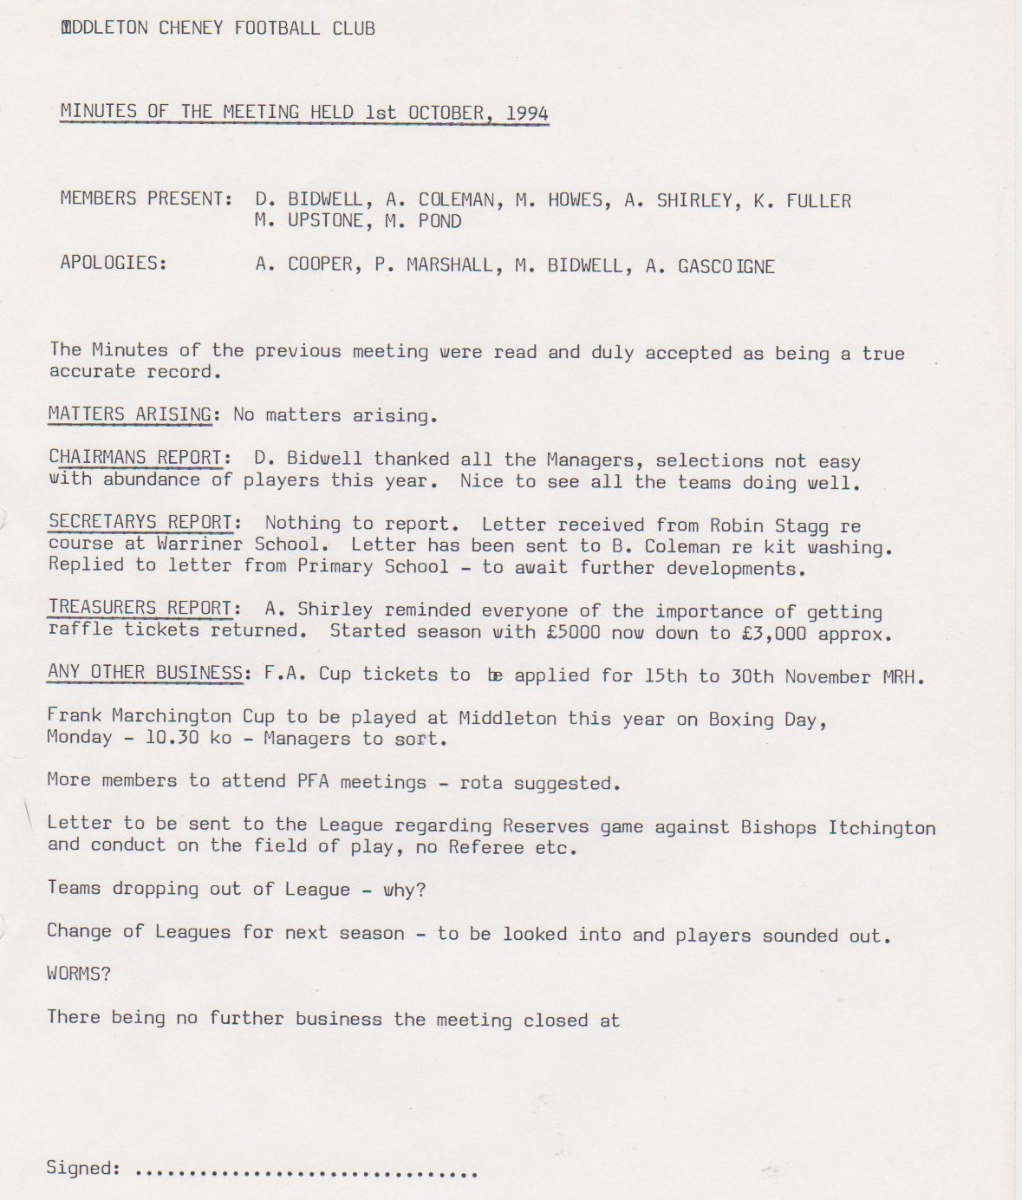

**General Committee Meeting**

**November 5th 1994**

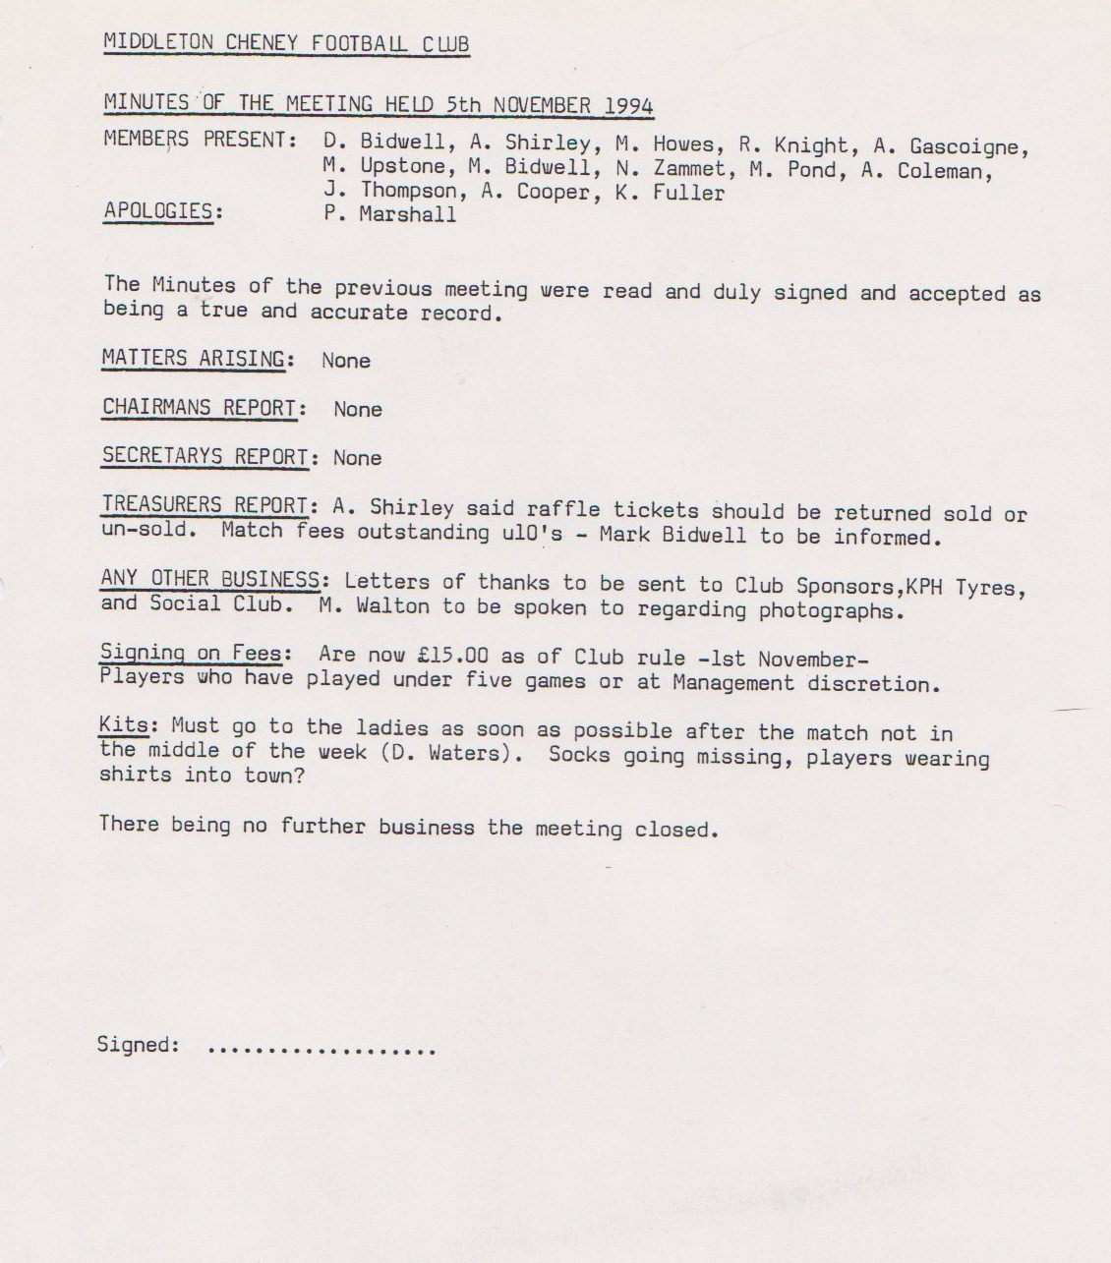

**General Committee Meeting**

**December 3rd 1994**

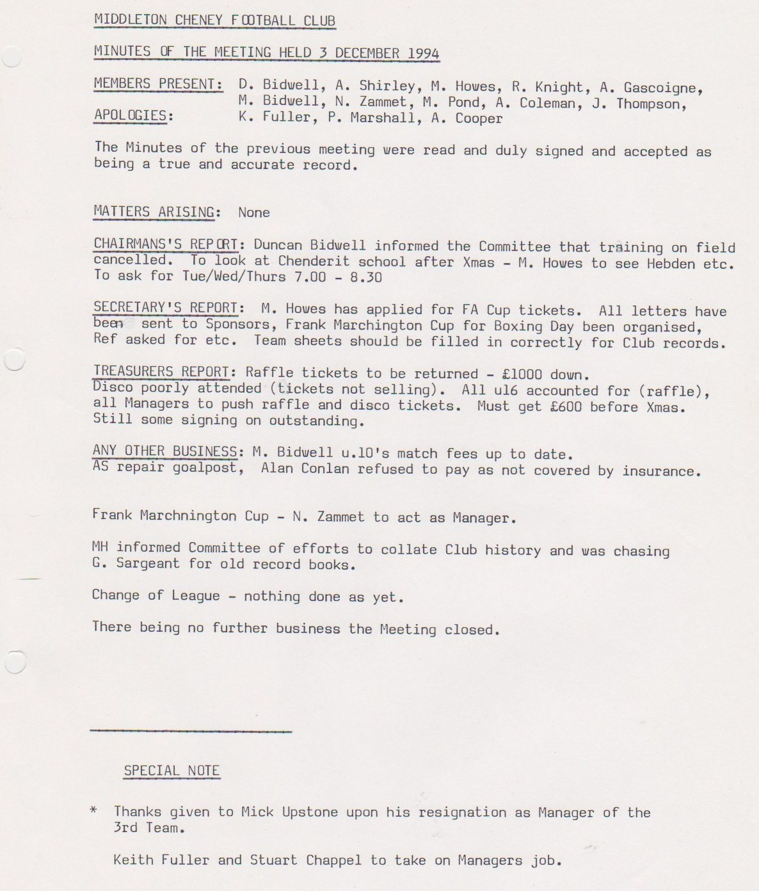

**General Committee Meeting**

**January 7th 1995**

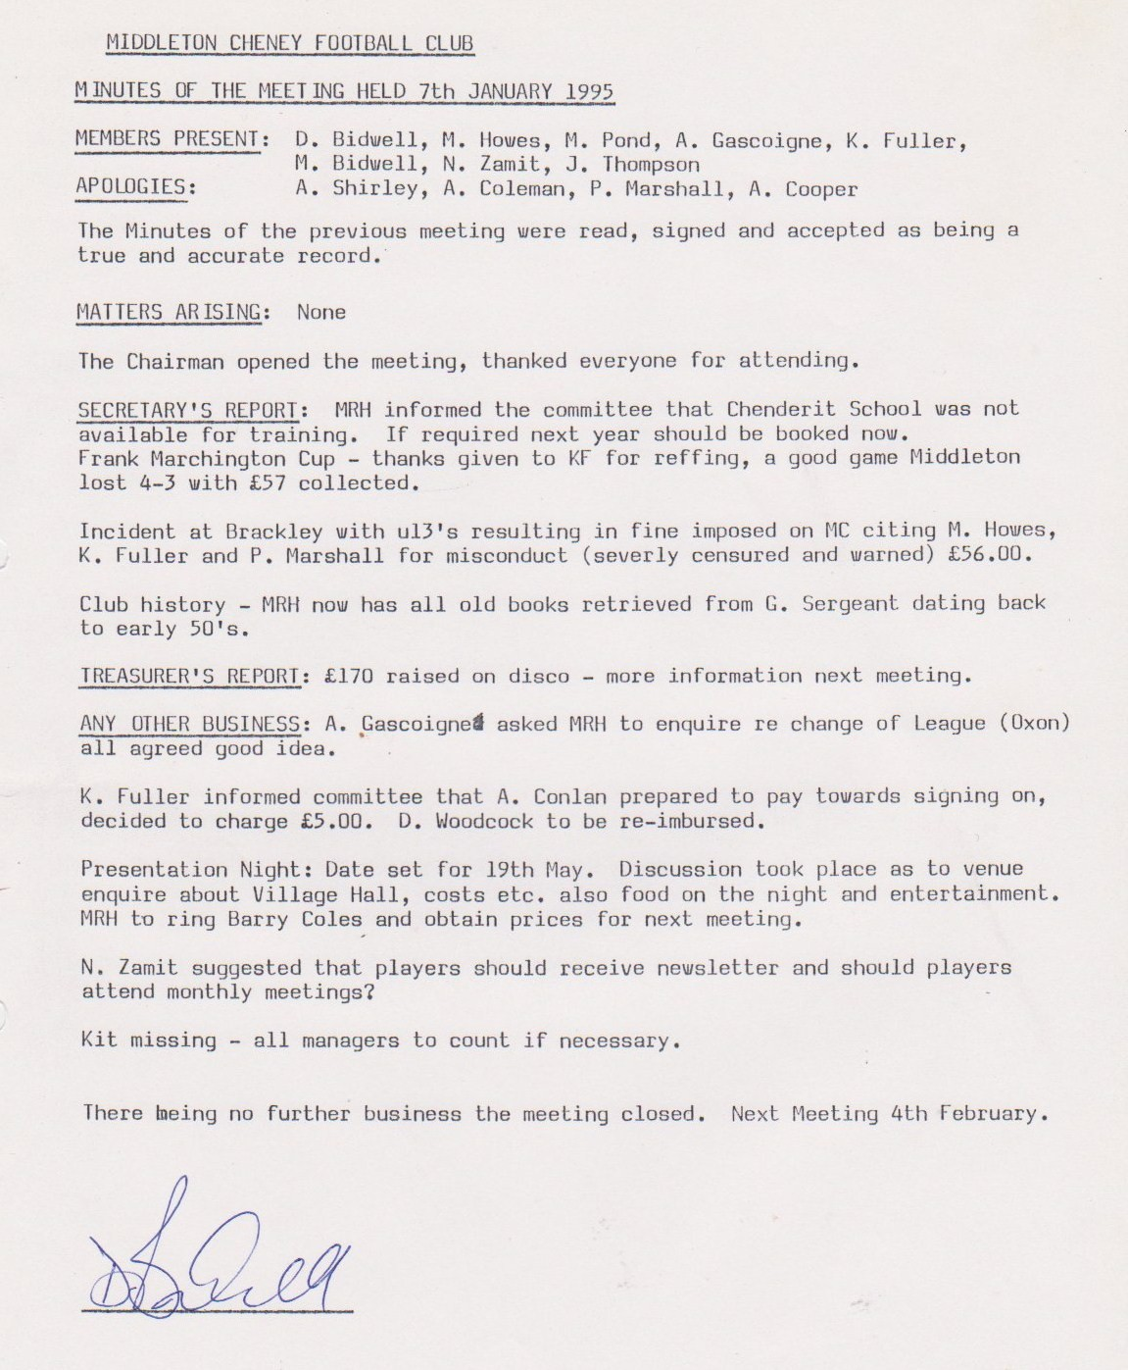

**General Committee Meeting**

**February 4th 1995**

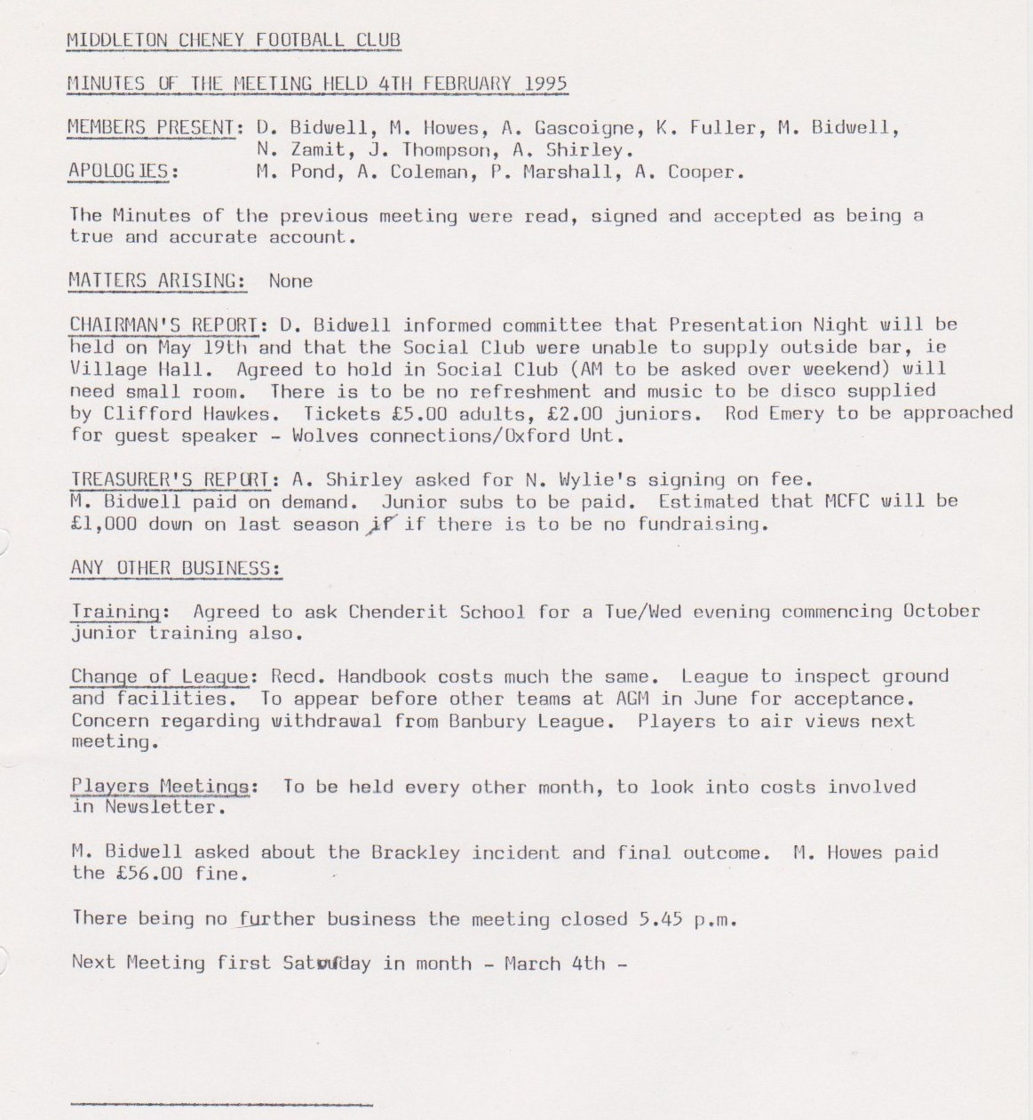

**General Committee Meeting**

**March 4th 1995**

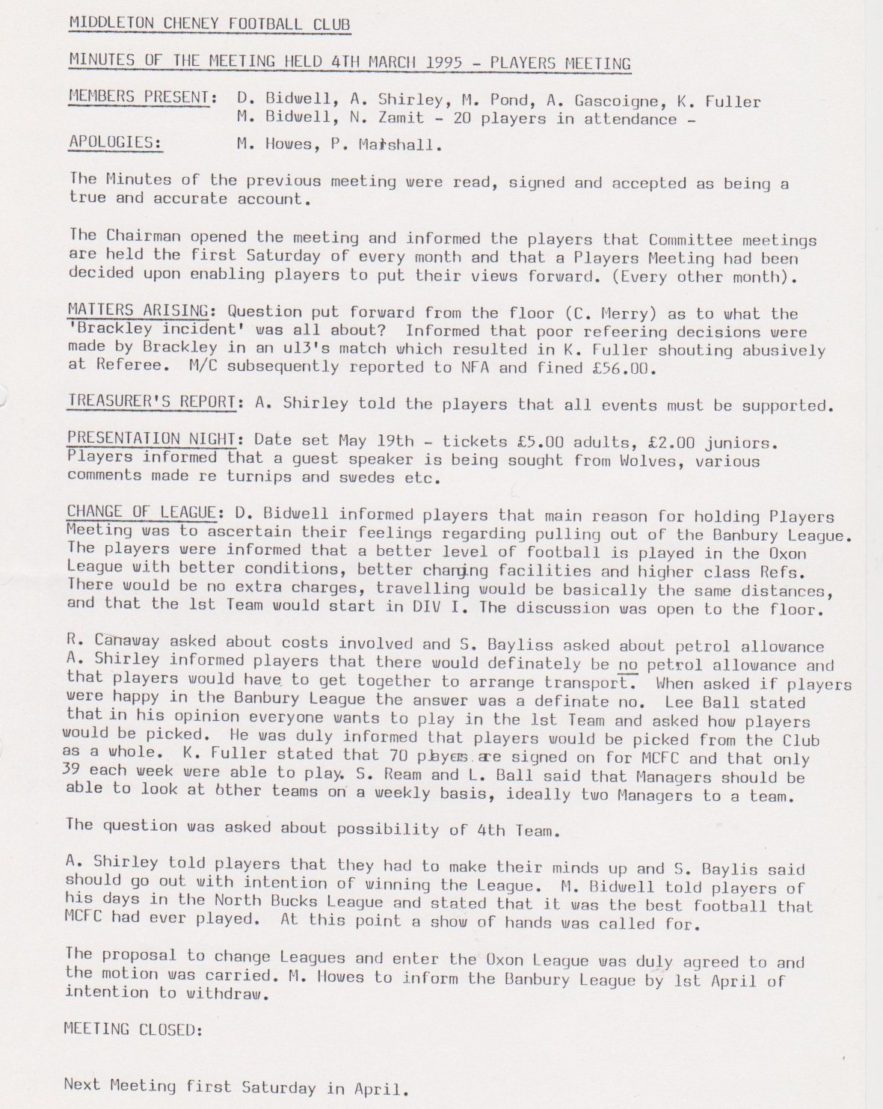

**General Committee Meeting**

**April 1st 1995**

